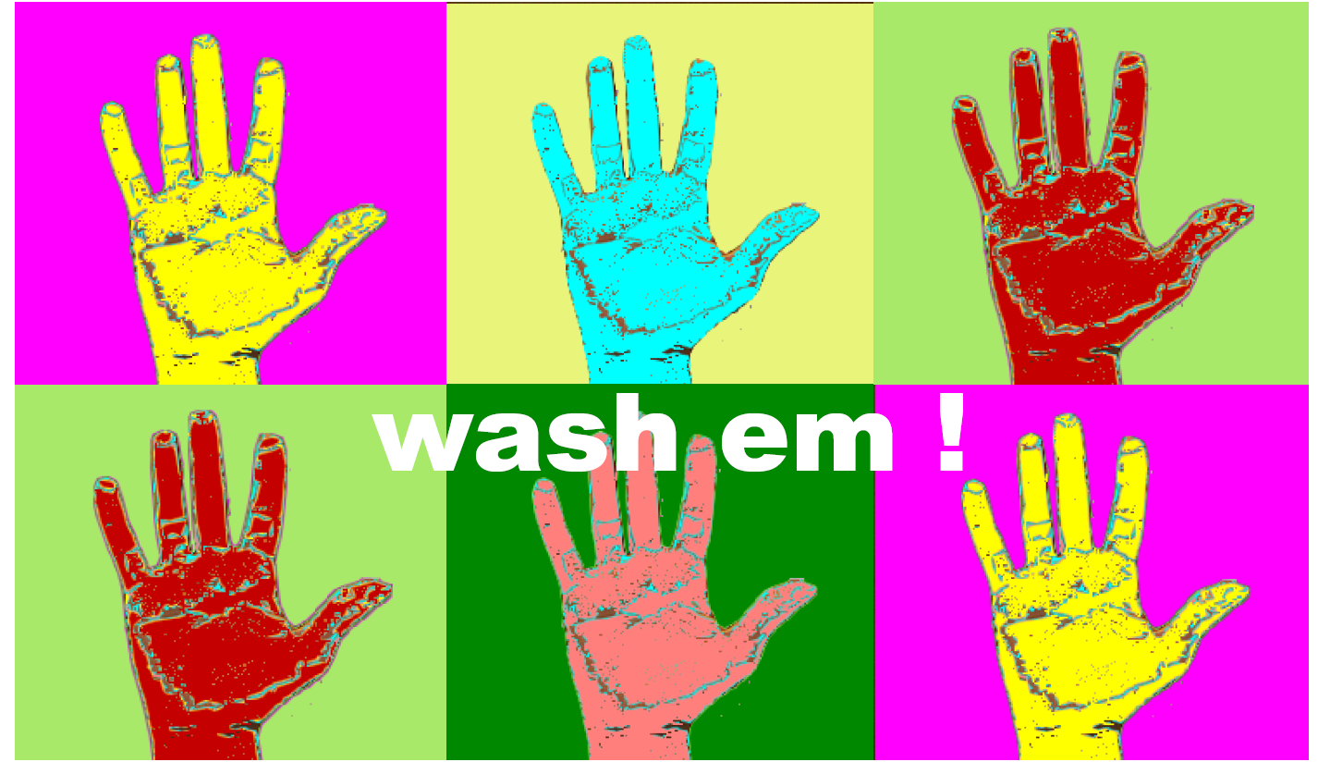
Jay Industries Inc.
Keep yourself and your co-workers healthy, wash your hands!

